

CSA0501-DATABASE MANAGEMENT SYSTEMS

LAB EXPERIMENTS DATE: 29/07/2026

EXPERIMENT 12-- Simple Programming using REPEAT, WHILE

AIM:
To learn and implement MySQL WHILE and REPEAT loop statements to execute a block of statements repeatedly based on a condition.

PROGRAM 1:

Write a function that uses a WHILE statement to build a string repeatedly until the value of the variable becomes greater than 5. Display the final string using a SELECT statement.

PROCEDURE:

Create a function using CREATE FUNCTION.

Declare an integer variable x and initialize it to 1.

Declare a string variable to store the result.

Use the WHILE loop to check whether x <= 5.

Append the value of x to the string.

Increment x by 1.

The loop terminates when x becomes greater than 5.

Display the final string using SELECT.

Program

DELIMITER //

CREATE FUNCTION while_example()
RETURNS VARCHAR(100)
DETERMINISTIC
BEGIN
DECLARE x INT DEFAULT 1;
DECLARE result_string VARCHAR(100) DEFAULT '';

WHILE x <= 5 DO
SET result_string = CONCAT(result_string, x, ' ');
SET x = x + 1;
END WHILE;

RETURN result_string;
END //

DELIMITER ;

Execute the Function

SELECT while_example();

OUTPUT:

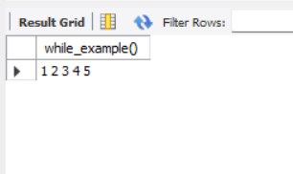

PROGRAM 2 – REPEAT LOOP

Write a function using the REPEAT statement which repeats the loop until income becomes greater than or equal to 4000.

PROCEDURE

- Create a function using CREATE FUNCTION.
- Declare the variable income and initialize it.
- Use the REPEAT statement.
- Increase the income inside the loop.
- Check the condition using UNTIL.
- The loop terminates when income >= 4000.
- Return the final income value.
- Display the result using SELECT.

PROGRAM

DELIMITER //

CREATE FUNCTION repeat_example()
RETURNS INT
DETERMINISTIC
BEGIN
DECLARE income INT DEFAULT 1000;

REPEAT
SET income = income + 1000;
UNTIL income >= 4000
END REPEAT;

RETURN income;
END //

DELIMITER ;

Execute the Function

SELECT repeat_example();

OUTPUT:
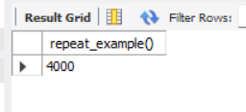

RESULT
Thus, the WHILE and REPEAT loop statements were successfully implemented in MySQL using functions. The WHILE loop repeatedly executed statements while the condition was true, whereas the REPEAT loop executed the statements first and terminated when the specified condition became true.

